Final Project Report — ICT Lab

University Name: National University of Computer & Emerging Sciences (NUCES)
Department: Computer Science
Course: Introduction to Information & Communication Technologies (CL-1000)
Project Title: Advanced Mathematics MCQs Quiz
Submitted By: Safee Imran 25K-0980
Muhammad Hasan Khan 25K-0722
Abdur Rehman 25K-0790
Submitted To: Osama Tahir
Semester: Fall 2025
Date: 5-December-2025

Abstract
This project is a web-based interactive quiz application designed to help students prepare for the NUST (National University of Sciences and Technology) Engineering Entry Test (NET) in the subject of Advanced Mathematics. The application features a clean, responsive interface built with HTML, CSS, and JavaScript, and includes 799 multiple-choice questions with support for LaTeX mathematical expressions via KaTeX. Key functionalities include timed questions, randomized question order, instant feedback with detailed explanations, score tracking, and a user-friendly interface suitable for self-paced learning. The project demonstrates the integration of front-end web technologies to create an engaging educational tool.

1. Introduction
The NUST NET is a highly competitive examination requiring thorough preparation in mathematics. Traditional study methods often lack interactivity and immediate feedback. This project addresses that gap by providing an online, interactive quiz platform where students can test their knowledge, receive instant explanations, and track their progress. The application simulates exam conditions with timed questions and provides a comprehensive set of practice problems spanning various topics in Advanced Mathematics. The use of modern web technologies ensures accessibility across devices without any installation requirements.

2. Objectives
- To develop an interactive web-based quiz application for NUST NET mathematics preparation.
- To support LaTeX rendering for proper display of mathematical equations and symbols.
- To implement a timer for each question to mimic real exam pressure.
- To provide instant feedback with explanations for both correct and incorrect answers.
- To allow randomization of questions to ensure varied practice sessions.
- To create a responsive and visually appealing user interface using Tailwind CSS and custom CSS.
- To ensure the application is easy to use, accessible, and free for all students.

3. System Design

System Overview
The application follows a client-side architecture with three main screens:
- Start Screen: Welcomes the user, displays instructions, and provides buttons to start the quiz or randomize questions.
- Quiz Screen: Displays one question at a time with four options, a countdown timer, and an explanation section that appears after answering.
- Result Screen: Shows the final score after quiz completion with an option to play again.

Input & Output
- Input: User clicks/taps on answer options, buttons to navigate, and timer expiration.
- Output: Visual feedback (color-coded right/wrong answers), score updates, mathematical equations rendered via KaTeX, and explanatory text.

4. Implementation
Languages & Technologies: HTML5, CSS3, JavaScript (ES6 Modules)

Libraries Used:
- Tailwind CSS (via CDN) for utility-first styling
- KaTeX for LaTeX math rendering
- Google Fonts (Inter) for typography
Development Environment: Visual Studio Code with Live Server extension

Key Features
- Dynamic Question Loading: Questions are loaded from an external JavaScript module (mcqs.js).
- Timer with Visual Feedback: 40-second timer per question that turns red and pulses when time is low.
- Math Equation Support: KaTeX processes LaTeX within questions, options, and explanations.
- Responsive Design: Works on desktop, tablet, and mobile screens.
- Question Randomization: Fisher-Yates shuffle algorithm ensures a unique order each session.
- Explanation Display: Detailed solution appears after each question is answered or time expires.
- Modal System: Custom modal replaces native alert() and confirm() for better UX.
- Social & Resource Links: Direct links to GitHub repository, Instagram, and Google Drive notes.

Code Snippet
JavaScript:
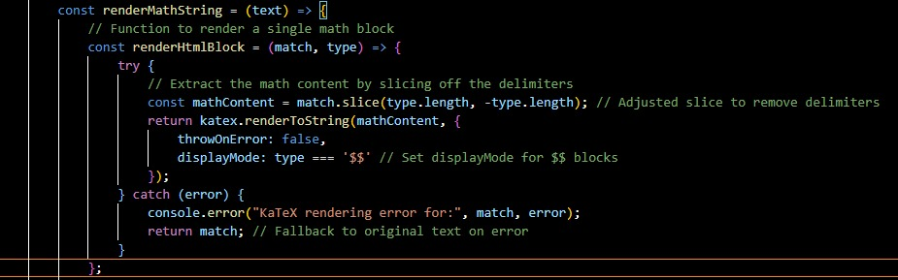

Sample Output
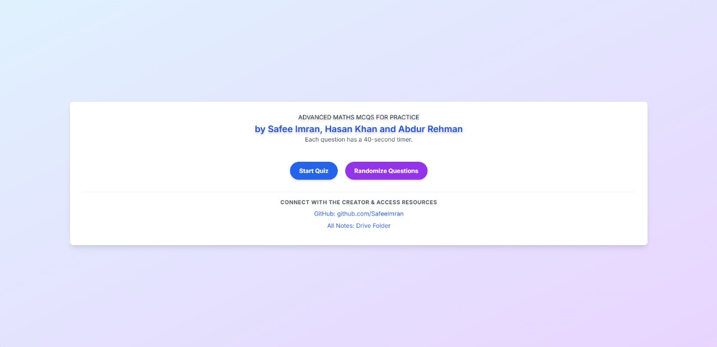

5. Testing & Results
The application was tested across multiple browsers (Chrome, Firefox, Edge) and devices (desktop, mobile). All features worked as intended:
- Questions loaded correctly from the external mcqs.js file.
- Timer accurately counted down and triggered next question on expiration.
- LaTeX rendering displayed complex equations without errors.
- Randomization produced different question orders on each session.
- Explanation container correctly showed/hid based on question state.
- Score calculation was accurate throughout the quiz.
- UI remained responsive and visually consistent on various screen sizes.
User Feedback: The interface was praised for its clarity, the timer added helpful pressure, and the explanations were considered valuable for learning.

6. Conclusion, Limitations & References
Conclusion
The Advanced Mathematics MCQs Quiz successfully meets its objectives by providing an interactive, accessible, and educational platform for NUST NET aspirants. It demonstrates practical application of front-end web technologies to solve a real-world educational need.
Limitations
- Currently relies on a single mcqs.js file; very large question sets may impact initial load time.
- No backend system for saving user progress or scores across sessions.
- No user authentication or personalized dashboards.
- Limited to multiple-choice format; cannot support symbolic or step-by-step input.
Future Enhancements
- Implement user accounts to track progress over time.
- Add topic-wise filtering of questions (Calculus, Algebra, etc.).
- Include a dashboard with performance analytics (weak areas, improvement over time).
- Develop a backend using Node.js or Firebase to store questions and user data.
- Add sound effects for correct/incorrect answers and timer warnings.
- Support for descriptive/long-answer questions with manual evaluation.
References
- MDN Web Docs – JavaScript, HTML, CSS
- Tailwind CSS Documentation
- KaTeX Documentation
- NUST NET Syllabus and past papers
- Fisher-Yates Shuffle Algorithm – Wikipedia
- Google Fonts – Inter font family
- W3Schools – Web development tutorials

